Diploma of water sanitation and hygiene

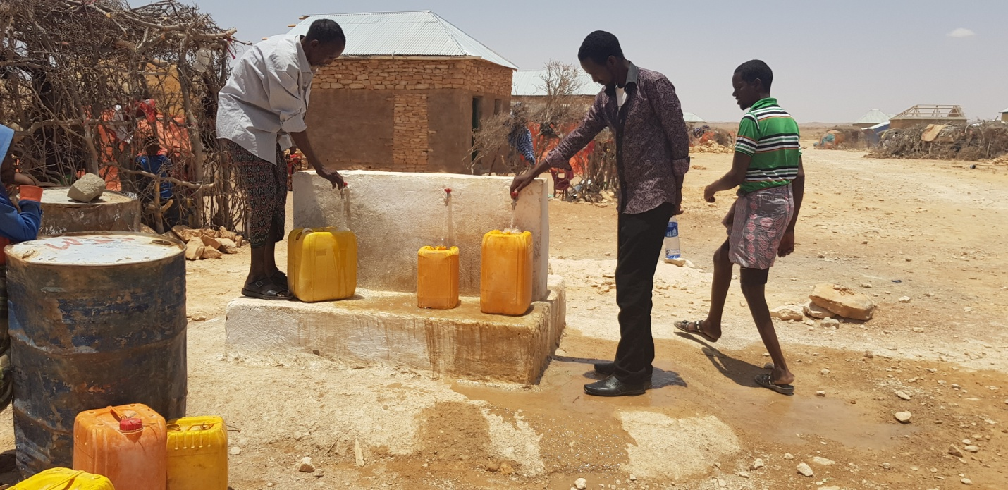

Submission of assignment 2 answer

31/1/2019

Pre: Eng Mohamed Farah Abdi

ANSWER:

1. Why is hand washing an essential aspect in WASH interventions?

Hand washing is essential in WASH interventions because is the barrier of infections that lead death to community without proper personal hygiene. Personal hygiene with hand washing is key essential of hygiene promotion. Hand washing can greatly reduce the chance of getting infections; mostly infections of the stomach and intestines, but also respiration (breathing) and skin infections. Also, hand washing can reduce the risk of diarrhea. This makes hand washing the best thing you can do to avoid diarrhea!. Hand washing in a community can help to prevent outbreaks of cholera and different kinds of flu. If childbirth takes place where there is not good hygiene, there is three times more chance that the mother could die. This is true both for births in the clinic or at home.  A clean birth leads to less risk of the mother dying or of the newborn getting an infection. It is very important to wash hands when handling a newborn because they can easily get infections. Ref: https://www.wvi.org/health/intervention-6-hand-washing-soap

Farther, washing hand can get benefit of reducing the risk of diarrhea and infections, washed hands smell nice. A person can feel better when hands are clean. Babies and infants dislike dirty hands.

Follows are ways germs inter human body and how we clear our hands to provide health body and environment:

1. Germs can spread many ways, including:

* touching dirty hands
* changing dirty diapers
* through contaminated water and food
* through droplets in the air released during a cough or sneeze
* on contaminated surfaces
* through contact with a sick person’s body fluids

1. **Washing Hands Correctly**

Here’s how to scrub those germs away. Wash your hands together often so they learn how important this good habit is:

1. Wash your hands in warm water. Make sure the water isn’t too hot for little hands.
2. Use soap and lather up for about 20 seconds (antibacterial soap isn’t necessary — any soap will do). Make sure you get in between the fingers and under the nails where germs like to hang out. And don’t forget the wrists!
3. Rinse and dry well with a clean towel.

To minimize the germs passed around your family, make regular hand washing a rule for everyone, especially:

* before eating and cooking
* after using the bathroom
* after cleaning around the house
* after touching animals, including family [pets](https://www.rchsd.org/health-articles/selecting-safe-pets/)
* before and after visiting or taking care of any sick friends or relatives
* after blowing one’s nose, coughing, or sneezing
* after being outside (playing, gardening, walking the dog, etc.)#ref: https://www.rchsd.org/health-articles/why-is-hand-washing-so-important/

Farther, on experience I received this course I applied to programs implementing the agency I working. The organization targeted villages affected by heavy rains and floods caused by a tropical cyclone that hit the Horn of Africa followed with recurrent droughts were affected in Awdal region, Somalia. These led los death of people, livestock has been wipe out and hundreds of farms destroyed by the cyclone floods. High numbers of people were fled to these villages seeking water and live saving assistances from the humanitarian agency.

We planned and constructed 50 latrines in IDP settlements of Lugahaya, Tuurka, Hul-xudhunle and Osoli, who were fled cyclone hit their locations. The number of users per each latrine was based on the sphere minimum requirement for latrine use per households, which are 21 individuals (Three household per latrine). Moreover, the latrines were also hygiene promotion especially hand washing and waste management. When the community provide sanitation facilities with hygiene promotion community behavior were changed and adopted WASH practices.

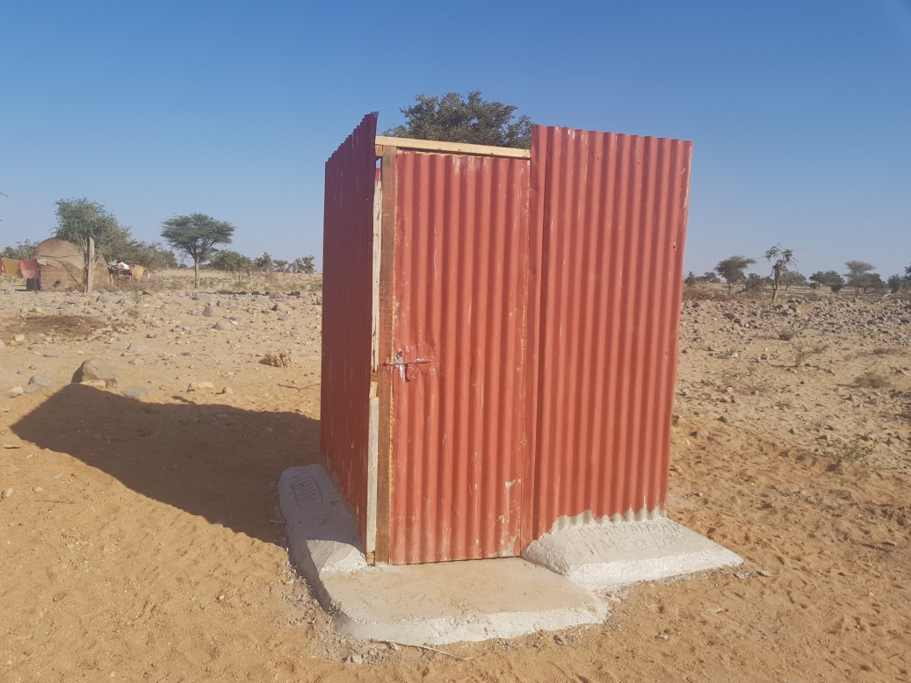

FIG: Completed construction of latrine in Lughaya lughaya district, Awdal region.

1. What are the main standards in WASH interventions in emergencies?

First, Access to adequate Water, Sanitation and Hygiene (WASH) services saves lives and is essential to uphold the health and dignity of the populations in need. The provision of water and sanitation infrastructure and services, coupled with the promotion of good hygiene practices, reduce the risk of water-related disease transmission, impacting positively in health and nutrition outcomes. The provision of WASH services is usually one of the highest priorities following the onset of any crisis, whether sudden or protracted, following a natural disaster or complex situation.

The main WASH standards in Emergency include:

1. WATER:

Objective of the intervention: To ensure that unrestricted access to and equitable access to safe and affordable drinking water is available and is consistent with Sphere minimum standards in terms of quantity, quality and accessibility. Interventions to ensure access to safe water. These can be done through supply of safe water by water trucking or piping and etc.

1. Sanitation: Objective of the intervention: To ensure that appropriate and equitable sanitation facilities are available to facilitate safe excreta disposal and waste management and clean bathing and laundry spaces are accessible to the affected population, paying special attention to the needs of women and girls and those in vulnerable situations.these can be achieved by construction and maintenance of sanititation facilities and and solid and liquid management. https://emergencymanual.iom.int/entry/37422
2. Hygiene promotion: Objective of the intervention: To encourage communities to adopt safer hygiene practices while also providing the necessary hygiene items to reduce the risk of occurrence of health threats. These follow three key factor matual sharing of knowledge, mobilization of affected communities and supply of essential material.
3. Drainage: It is of WASH actors' responsibility to ensure adequate drainage from the WASH facilities that are implemented, usually connecting it to existing storm water drains, natural drainage canals or enabling it to infiltrate to the ground. In camp settings, storm water (in some cases flood water or raising groundwater) drainage is the responsibility of the site planning or camp management agency. Anyhow, WASH actors are usually asked to lead drainage and flood mitigation activities in camp settings given the innate technical expertise in hydraulics, capacity to scale up technical human resources and availability of equipment and materials (i.e. pumps, pipes, etc.).

The Sphere standards describe the humanitarian actions that should be taken in the event of an emergency in order for ‘disaster-affected populations to survive and recover in stable conditions and with dignity’ (Sphere Project, 2011). In the section on water supply, sanitation and hygiene promotion, there are several standards in different categories, as shown in Figure

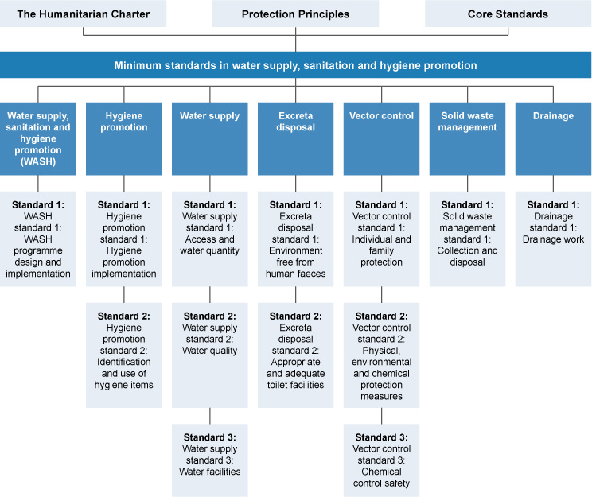

1. Waste Management is becoming one problem in the emergencies. Why?

Waste is one thing that lead unhealthy without proper management of waste, the wastes can generate illness to the community, these include contamination of water, production of rodents and flies that contaminate water and food and community get sickness, if the community gives attention the problem rise from the waste. The problem from the waste can be illuminate waste management and that is to form committee that help community for give awareness and management. Every person on the community should manage wastes starting himself, home and publically for example during public campaign. Wastes are two solid and liquid, to avoid problems from waste solid waste must collect and burn special place, liquid waste should make drainage system and treat to reduce contamination of water and the environment.

1. Discuss how environmental health and sanitation affect the nutritional status of the vulnerable groups

Proper sanitation and hygiene and safe drinking water can reduce undernutrition and stunting in children by preventing diarrhoeal and parasitic diseases, and damage to intestinal development (environmental enteropathy). According to the [World Health Organization](http://apps.who.int/iris/bitstream/10665/43840/1/9789241596435_eng.pdf), roughly 50% of all malnutrition is associated with repeated diarrhea or intestinal worm infections as a direct result of inadequate water, sanitation and hygiene. This does not capture the subclinical infections from environmental enteropathy, which[current research is revealing as a significant factor for poor growth and undernutrition](http://onlinelibrary.wiley.com/doi/10.1111/mcn.12220/abstract). When children are undernourished, their resistance to infection is lowered and they are more susceptible and more likely to die from diarrheal disease and other infections. In fact, [diarrhoea](http://www.wvi.org/child-health-now/diarrhoea) is the second-leading cause of death globally in children under five years. Where children regularly suffer from diarrhoea, they are also very likely to be malnourished as a result. For infants, particularly those under six months of age, diarrhea can cause permanent damage to intestinal development, reducing a child's ability to absorb nutrients. https://www.wvi.org/nutrition/nutrition-and-wash

1. Assuming you have been appointed to head an organization dealing with health development in your area, describe the critical factors that you will consider in planning for health service in that area.

The critical factors that will consider planning for health service include:

* High cost of care
* Inadequate or no insurance coverage
* Lack of availability of services
* Lack of culturally competent care

These barriers to accessing health services lead to:

* Unmet health needs
* Delays in receiving appropriate care
* Inability to get preventive services
* Financial burdens
* Preventable hospitalizations

Pre: Eng Mohamed Farah Abdi